Create a webpage with Bootstrap styles

- Open Sublime and click “File” at the top left corner and select “Open Folder…”
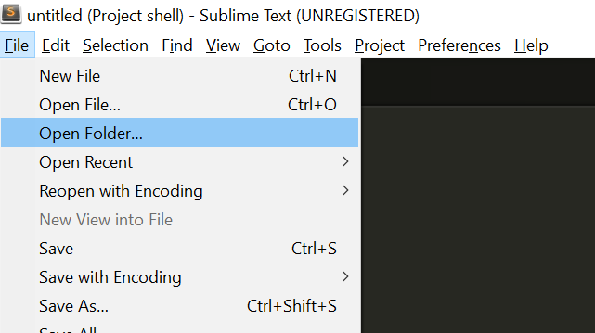
- Locate your “Bootstrap” folder (in the ‘dev’ folder you created in Hands-on Project 1) and select it
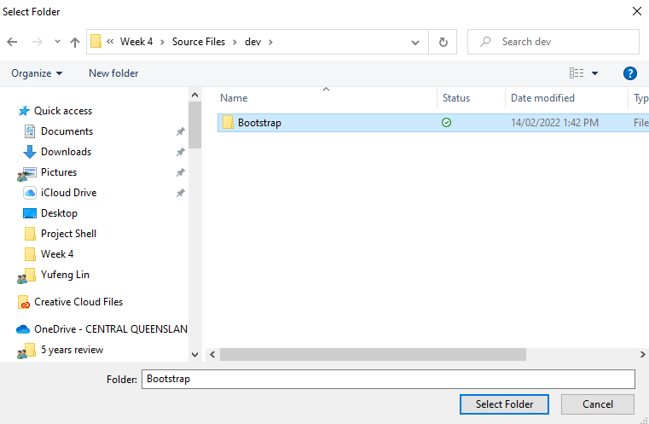
- You should now have something like this on the left hand side bar
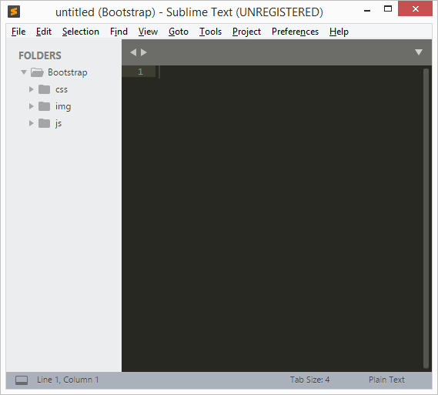
- Right click “Bootstrap” and select “New File”. A new tab (untitled) should open on the right section of sublime text.
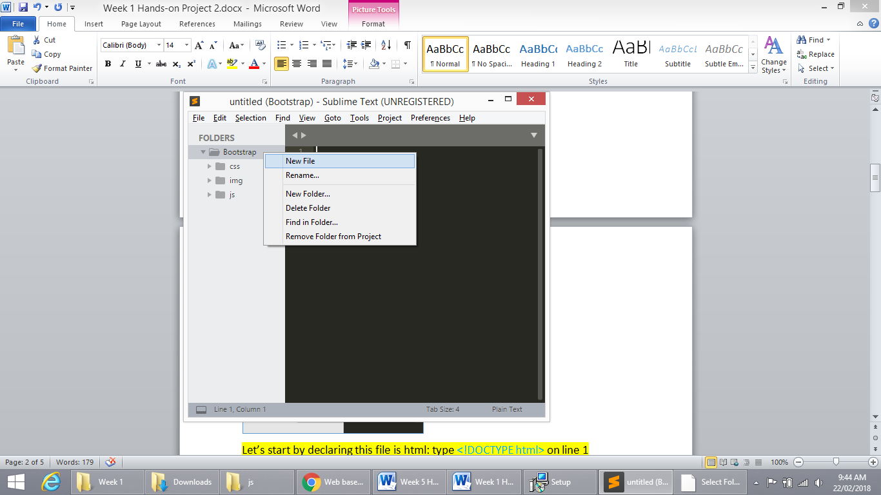
- This file is going to act as an index page for our website. Let’s start by saving the page into our “Bootstrap folder” (File Menu -> Save, or press CTRL+S). Give it a name of index.html.
By saving the file as a html type, Sublime text will add syntax highlighting (give special words certain colours).

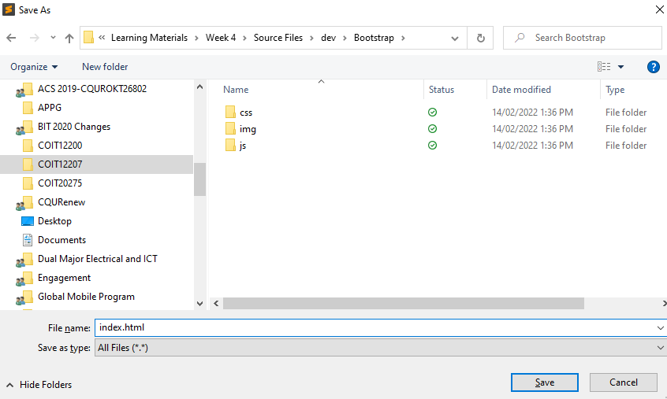

- Once it’s saved, it will appear in your left hand side bar.
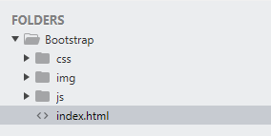

- Next, we can start coding our page. First, we should declare this file is html. Type:
<!DOCTYPE html> on line 1
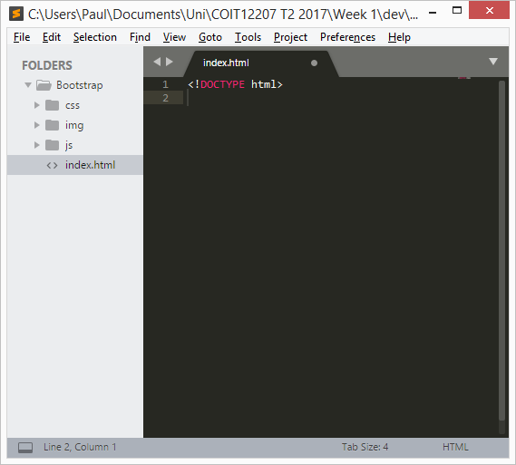
- Then let’s wrap everything in the html tag. Give it some space in between.
Note: we add the attribute ‘lang’ to our html tag with the value of ‘en’. This sets the language of our page as English. Although a web browser will still render your page find without this tag, it is recommended to include it to keep your code inline with the HTML standard coding conventions.
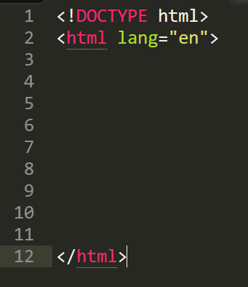
- Next, let’s define our html head. We start by defining some metadata:
This is standard metadata you should declare in all your HTML files.
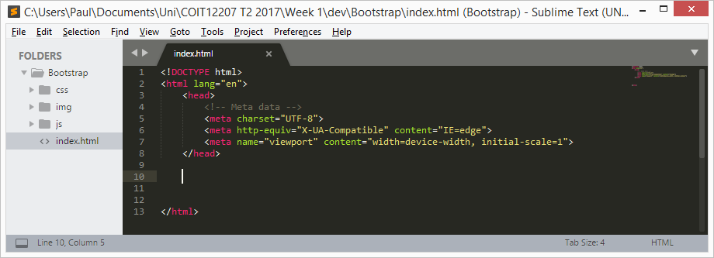

- Then we add in references to our jQuery library and Bootstrap libraries
These references point to the folders and files you made in Hands-on Project 1. For example, look at the first script tag. You will see the ‘src’ attribute has a value of ‘js/jquery-3.6.0.min.js’. If you go into your ‘js’ folder, you should see a file named ‘jquery-3.6.0.min.js’ (your minor and patch version may be different; please use your specific minor and patch versions; e.g. jquery-3.<minor>.<patch>.min.js, where <minor> and <patch> will be numbers).
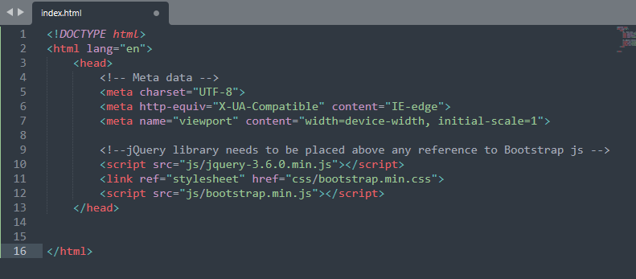
Note: at the time of July 2023, the most recent jQuery version is 3.7.0. You should replace the
<script src=”js/jquery-3.6.0.min.js”></script> by
<script src="js/code.jquery.com_jquery-3.7.0.min.js"></script>
Check your js folder for the file name you downloaded.
- Next, add in our page title
The page title is what appears in the title bar of your browser. In this example, we just set it to ‘Bootstrap’, but you could make it anything you want.
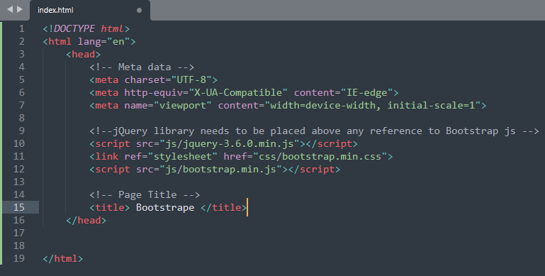

- Our html head is done! Now let’s move on to the html body and put in some content.
Firstly, we add a heading (<h1>). Below that we add a <div> with some text. Notice the div has some classes set (alert and alert-info). These classes set the css which will determine how the div is rendered to screen. When you run the page, you will see what an alert and alert-info looks like.
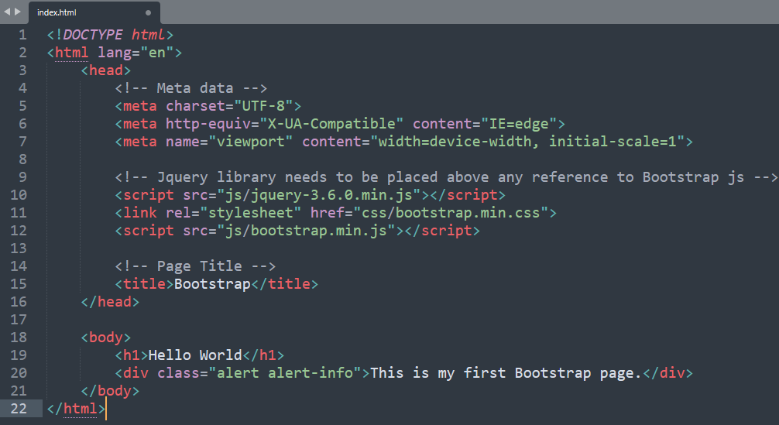

- If you haven’t already, be sure to save your file.

- Let’s have a look at our first webpage with Bootstrap styles. Go to your Bootstrap folder and find index.html. Your browser should open and display a page similar to that shown below:
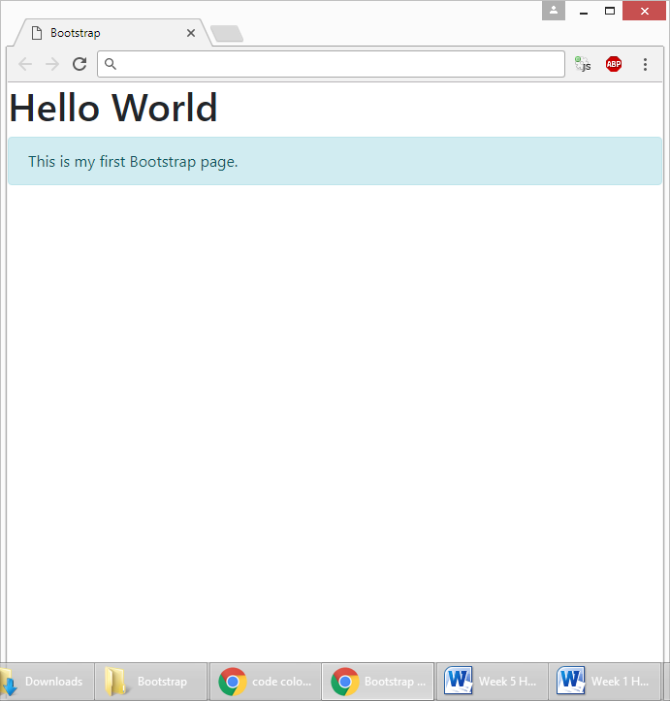
You should see the alert and alert-info classes make our div appear blue. We look at Bootstrap classes in more detail in later weeks.
(Bootstrap Alerts resource: https://www.w3schools.com/bootstrap/bootstrap_alerts.asp )
- You have now completed Hands-on Project 2.

(Updated on 23 July. 2023)

